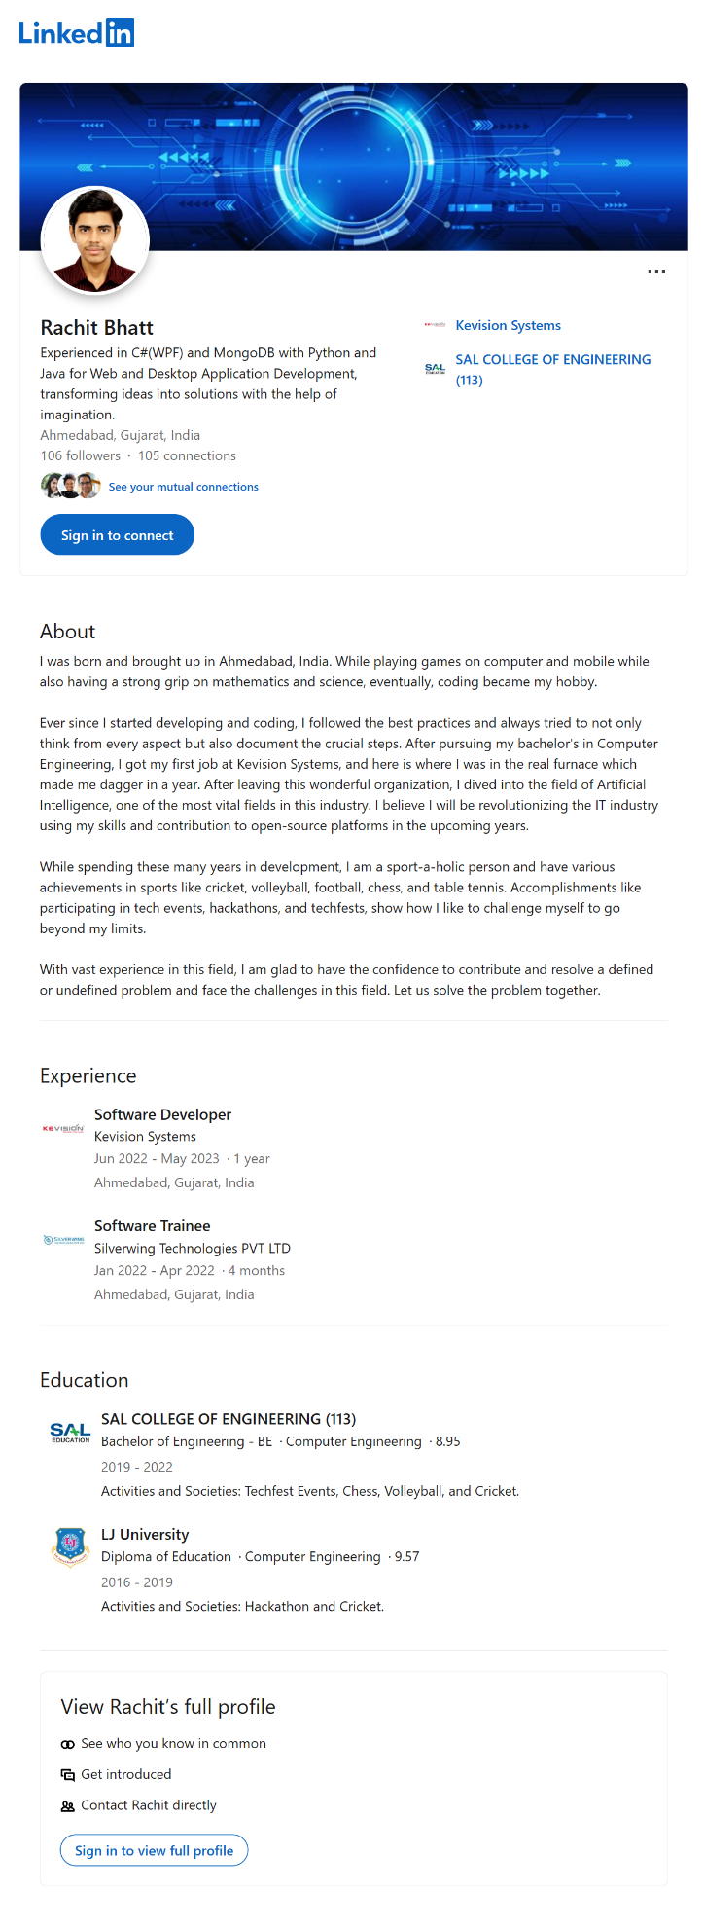
Name: Rachit Bhatt | Student-ID: C0902810
Assignment: LinkedIn Profile | Week: 9
URL: https://www.linkedin.com/in/rachit-bhatt | Course: AIMT-Fall-2023
Skills: Python, Data Science, Artificial Intelligence, Machine Learning, and Cloud Computing.

